Summary of activities:

1. VMKernal Adapter Configuration for vSAN
2. Configuring vSAN
3. Key Takeaways & Results

Before you begin:

* Each host must have a total of 2 disks available for vSAN. So 3 total including the disk which has ESXi installed  
  + Boot Disk: ESXi
  + Cache Disk: SSD, M2 NVMe or USB Flash Drive
  + Capacity Disk: SSD, M2 NVMe or HDD.
* Ensure your 2 vSAN disks (cache and capacity) have been cleared of their partitions
* If you are using USB flash drives as either storage or cache please be sure to complete these steps
  + Login to each host via SSH
  + Run the following command: **esxcli system settings advanced set -o /VSAN/AllowUsbDisks -i 1**
  + Log in to each host’s web interface
  + Go to Manage > System > Advanced Settings
  + Use the search bar on the right-hand side to search for **Disk.AllowUsbClaimedAsSSD** and set to 1
  + Plug in your USB Flash drive devices and ensure they are marked as **SSD** and not HDD. If they are not marked as an SSD device, you must mark them as a flash device.

1. Ensure each host has a dedicated VMKernel Network Adapter set for vSAN.  
   1. Click on the host you wish to configure a VMkernel adapter for vSAN
   2. Click on **Configure**
   3. Click on **VMkernel Adapters**
   4. A screenshot of a computer

      Description automatically generated with medium confidenceClick on **Add Networking**
   5. In this example, I am using 10.0.0.3 which is **esxi2**   
        
      (Steps continue on next page)
   6. On *Select connection type* select **VMkernel Network Adapter**Text

      Description automatically generated
   7. For a target device, since this is a lab, click on **Select an existing standard switch**. Then click **Browse**. Select **vSwitch0** for now. In an enterprise environment, you may have a different switch setup for this.
   8. On the *Port Properties* section, label the Network as **vSAN-ESXI2** or whatever else you want to name it. Just place **vSANAdapter** if you don’t know what to set it to.  
        
      (Steps continue on next page)

* 1. Also within the *Port Properties* section, check the box that says **vSAN** under *Enabled Services*.  
       
     A screenshot of a computer

     Description automatically generated with medium confidence  
       
     (Steps continue on next page)
  2. Within *IPv4 Settings* use **Obtain IPv4 settings automatically** to keep things simple. If you know your network is setup differently and do not have a DHCP server available, you can use a static IP if you wish.  
       
     Graphical user interface, text

     Description automatically generated
  3. On the *Ready to Complete* page, click on **Finish.**A screenshot of a computer

     Description automatically generated with medium confidence
  4. Perform the Vmkernel adapter creation for vSAN on all three hosts using the same steps above.

1. Configuring vSAN
   1. Click on the Cluster you wish to configure vSAN
   2. Click on **Configure**
   3. Scroll all the way to the bottom of the configure page and you will see **vSAN**, drill down to see the **Services**, select that and you will see the vSAN Services Page open.  
      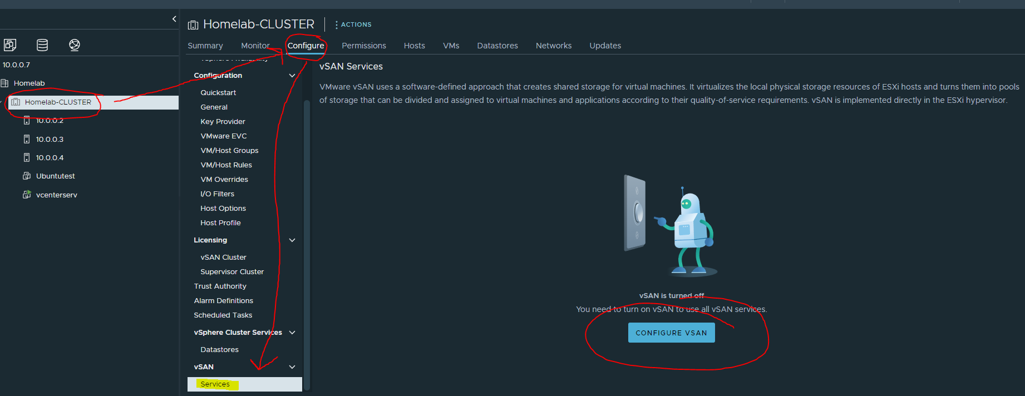
   4. Click on **Configure vSAN**  
      (Steps continue on next page)
   5. We will be creating a **Single Site Cluster** as all of our hosts are in the same “datacenter” and right next to each other on the same network.  
        
        
      Graphical user interface, text

      Description automatically generated
   6. On the next page, *Services*, keep everything set to default and click **Next**(Steps continue on next page)
   7. On the Claim disks page, you will select your **Capacity** and **Cache** disks. For my setup, I am using USB drives, marked as Flash SSDs as my Cache disks. I am using an internal NVMe M2 drive as Capacity. This is NOT supported in an enterprise environment. However, in an enterprise environment you need at least 2 disks available for vSAN (3 if you count the ESXi install). You need 1 SSD for caching, and 1 SSD/HDD for Capacity.  
        
      Graphical user interface, text

      Description automatically generated
   8. On the review page, review your settings and click **Finish**.
   9. vSphere will then update the vSAN configuration on all of your hosts that you had selected for the configuration. Keep an eye on the recent tasks bar at the bottom of the screen to see the progress and be patient.  
        
      A screenshot of a computer

      Description automatically generated  
        
      (Steps continue on next page)

* 1. When it is completed, all three nodes should appear as healthy.  
       
     A screenshot of a computer

     Description automatically generated  
       
     (Key take aways on next page)

1. Key Take-aways
   1. During my installation, the third node, **esxi3** had failed. I spent about 3-4 hours troubleshooting this alone. I used different USB drives, but it would not work, the error claimed that the cache drive (USB drive) was failing. After extensive troubleshooting, I had removed the host from the cluster entirely and rebooted it. Upon reboot, I attempted to clear to partition tables from the Capacity and Cache drives. They would not clear. I discovered that the vSAN datastore was leftover on esxi3, and it would not let me delete it.   
        
      I had to follow the steps of this guide: <https://www.virtualizationhowto.com/2021/03/force-delete-vsan-datastore-from-esxi-host/>  
      1. Take host out of cluster (done already)
      2. Place host into maintenance mode (done already)
      3. Open SSH to Esxi3 (this is where I began the steps)
      4. Connect via SSH to Esxi3
      5. Run command: **esxcli vsan cluster leave**
      6. Run command: **esxcli vsan cluster get** (to make sure it left the cluster)
      7. Then I ran **esxcli vsan storage list** to retrieve the UUID of the vsan storage group.
      8. After retrieving that, I executed **esxcli vsan storage remove --uuid vsanuuidhere**
      9. After removing the vsan storage based on UUID, I went back into the web interface and cleared the partition tables on the USB drive (Cache) and the NVMe M2 drive (Capacity).
      10. I rejoined the host to the cluster and allowed it to apply it’s cluster settings and then re-attempted to create the disk group. It worked this time and my vSAN cluster was fully configured.
   2. 2nd key takeaway: If you are going to use vSAN in enterprise, make sure to have like a billion hosts instead of 3. You need 3 to fully support vSAN.